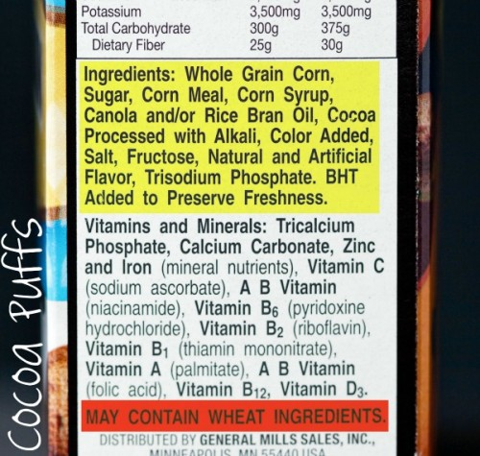

For more information, call us at 1-800-241-COCO or visit our website at www.cocoflakes.com

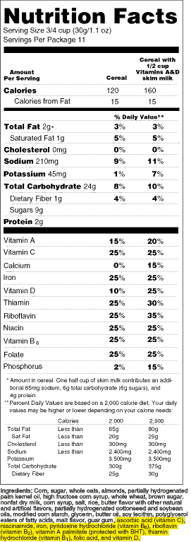



Coco Flakes

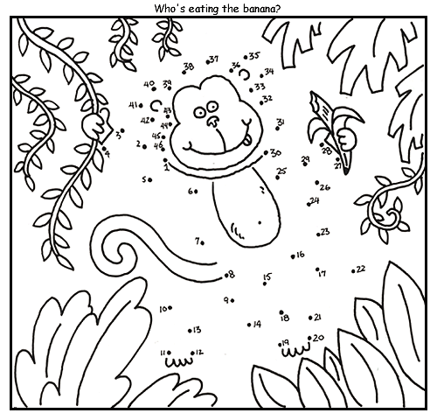

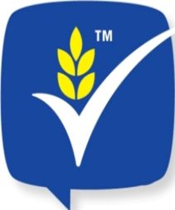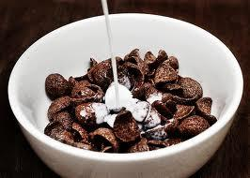

***S & P corporation’s***

**Collect 10 trophies on the side. Take them to a store that provides Coco Flakes. You would receive a toy and a free box of Coco Flakes.**

**411 g**

**CEREAL/CÉRÉALES**

**ENLARGED TO SHOW TEXTURE**

**AGRANDIES POUR MONTRER LA TEXTURE**



Coco Flakes

**NATURAL COCOA FLAVOUR**

**TASTE THE CHANGE**